Using AWS IAM to Integrate with Azure Active Directory

Contents

Scope 1

Problem Statement 1

Introduction 1

1. Azure Active Directory (Azure AD) 1

2. What is AWS IAM? 1

3. Federation 1

4. How does SSO works? 2

Implementation Steps: 4

Step 1: Configure the Azure Enterprise Application 4

Create Application: 4

Configure SAML: 7

Step2: Configure Target AWS Accounts 9

Create Identity Provider: 10

Create Role: 11

Create a policy: 17

Create User: 18

Step3: Integration Test 20

Perform Provisioning: 20

Test the Connection 22

Assign Users: 23

Test Application: 24

Useful Link: 26

**Document Name:** Using AWS Single Sign-on to Integrate with Azure Active Directory

**Owner:** Bhagyashree Patle

# Scope

We can use Azure AD to integrate with AWS IAM. The integration enables Azure AD users to login directly to the Amazon AWS console using their Azure AD credentials. If the user is logged into their AzureAD account already, then the sign-on to AWS is seamless without prompting for a new login.

# Problem Statement

How to use AWS IAM to Integrate with Azure Active Directory and how to provision user and group information from Azure Active Directory using the System for Cross-domain Identity Management (SCIM) v2.0 protocol.

# Introduction

## Azure Active Directory (Azure AD)

Azure Active Directory (Azure AD) is a cloud-based identity and access management service. Azure AD helps users sign up to multiple services and access them anywhere over the cloud with a single set of login credentials.

## What is AWS IAM?

Amazon Web Services (AWS) is a cloud IaaS platform that offers compute power, reduced management overhead, simplified implementation, and data storage for organizations looking to move away from on-prem hardware.

The general purpose of AWS IAM is to help IT admins manage AWS user identities and their varying levels of web-based access to AWS resources. Using AWS IAM, organizations can obtain increased control over who has permission to provision, deprovision, and access which assets from the AWS console, ensuring that IT teams can securely monitor access to their AWS resources. Beyond the scope of AWS’s services, AWS IAM struggles to authenticate users to the Linux and Windows systems themselves, applications, networks, and more without being integrated with a directory service.

## Federation

Federation means organization. Federation is a service that allows users to login into different Applications or Websites across different domains using a single set of login credentials.

With federated single sign-on, Azure AD authenticates the user to the application by using their Azure AD account.

Federated SSO supports all the authentication protocols like SAML, OAuth, and OIDC to authenticate users into applications. SAML is Security Assertion Markup Language it’s used for enables browser single sign on. It is an XML based authentication.

How does SSO works?

Single Sign On is based on trust relationship between Service Provider and Identity Provider. The authentication is based upon the token exchange between Service Provider and Identity Provider. The login information is send by identity provider to service provider. In SSO, the login data take in form of tokens which contains identifying bits of information about user like user name or email.

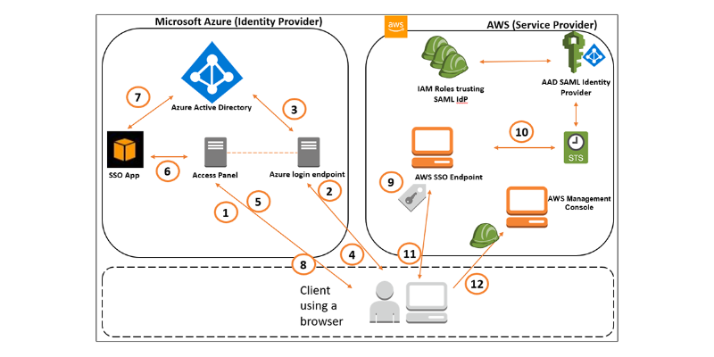

Figure SAML federation between Azure AD and AWS

**Explanation of above diagram:**

1. User opens a browser and navigates to Azure AD MyApps access panel (myapps.microsoft.com).
2. If the user isn’t authenticated, she’ll be redirected to the login endpoint for authentication.
3. User enters her credentials and the login endpoint will verify them against Azure AD tenant.
4. Upon successful login, user will be redirected back to the access panel.
5. User will see the list of available applications, including the AWS Console app, and will select the AWS Console app icon.
6. The access panel redirects the user to the federated application endpoint, passing the application ID of the AWS IAM Identity Center app.
7. The AWS IAM Identity Center application queries Azure AD and generates a SAML assertion, including all the AWS IAM roles assigned to the user.
8. SAML assertion is sent back to the user.
9. User is redirected to AWS federation endpoint, presenting the SAML assertion. The AWS federation endpoint verifies the SAML assertion. The user will choose which of their authorized roles they currently want to operate in. Note: If there’s only one role included, the selection is automatic.
10. The AWS federation endpoint invokes the AssumeRoleWithSAML API of AWS Security Token Service (STS) and exchanges the SAML token with temporary AWS IAM credentials.
11. Temporary IAM credentials are used to formulate a specific AWS Console URL that’s passed back to the client browser.
12. User is redirected to AWS Management Console with permissions of the assumed role.

# Implementation Steps:

## Step 1: Configure the Azure Enterprise Application

In the Azure portal, choose **Azure Active Directory**, **Enterprise Applications**. Select **create your own application** and specify the app name.

### Create Application:

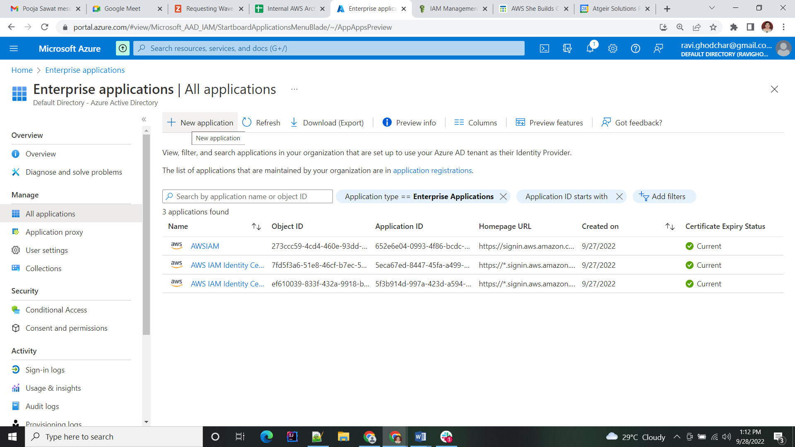

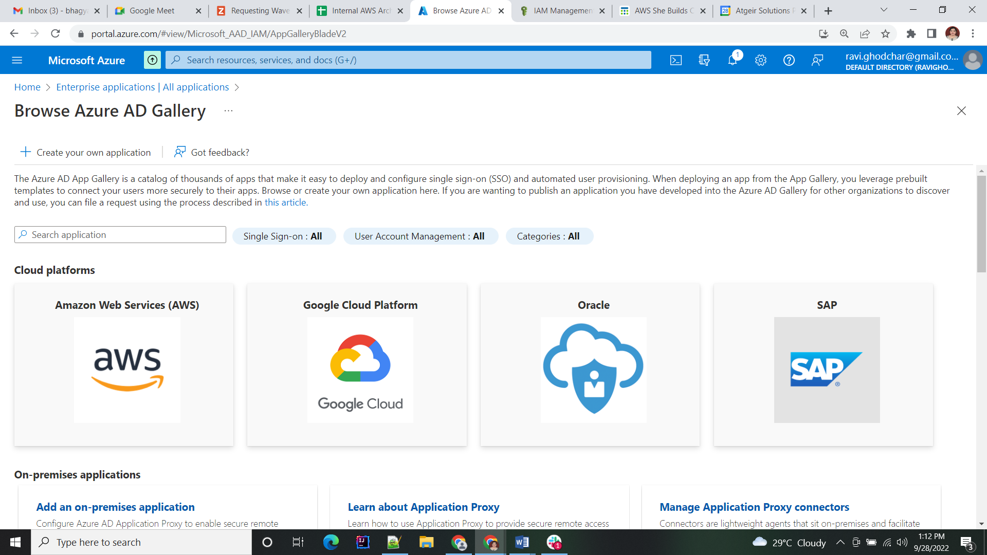

Select aws Cloud platform.



Select AWS Single-Account-Access.

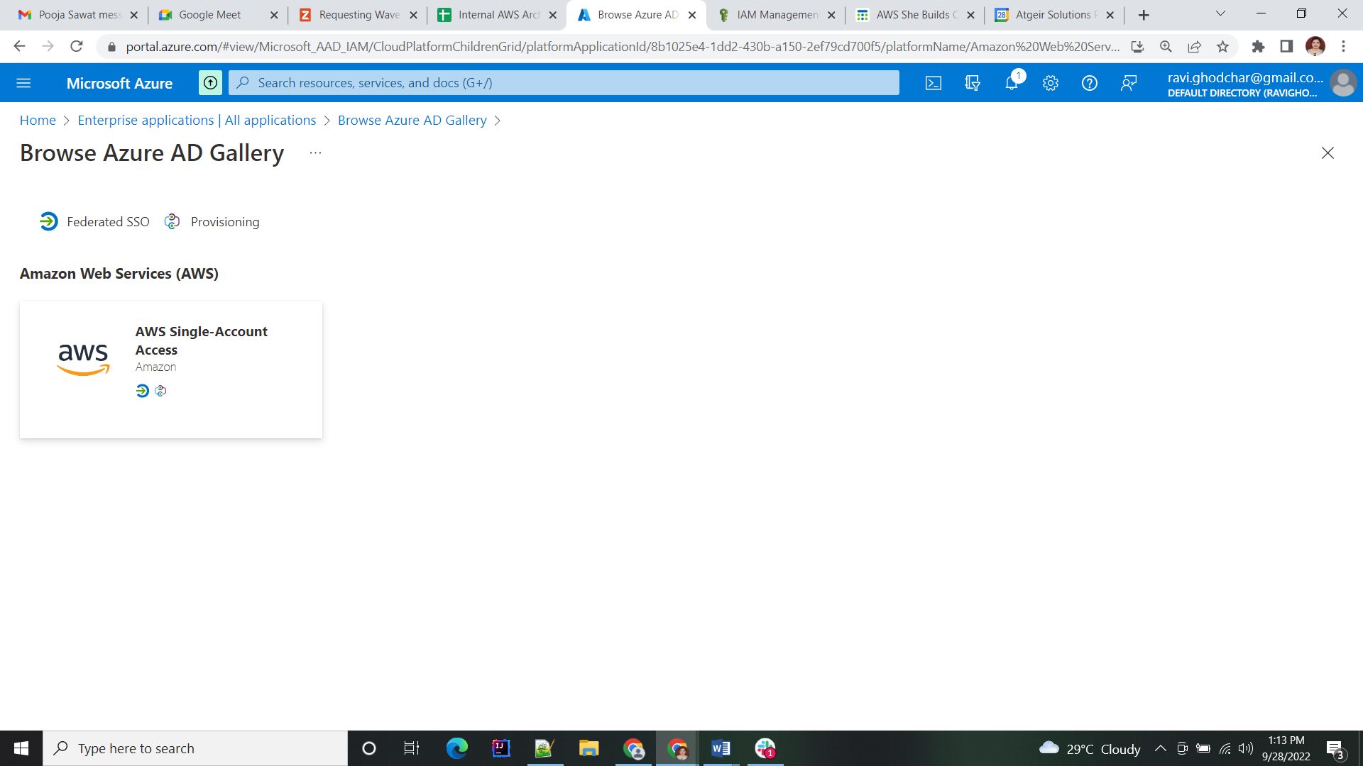

Enter the Application Name as per you want.

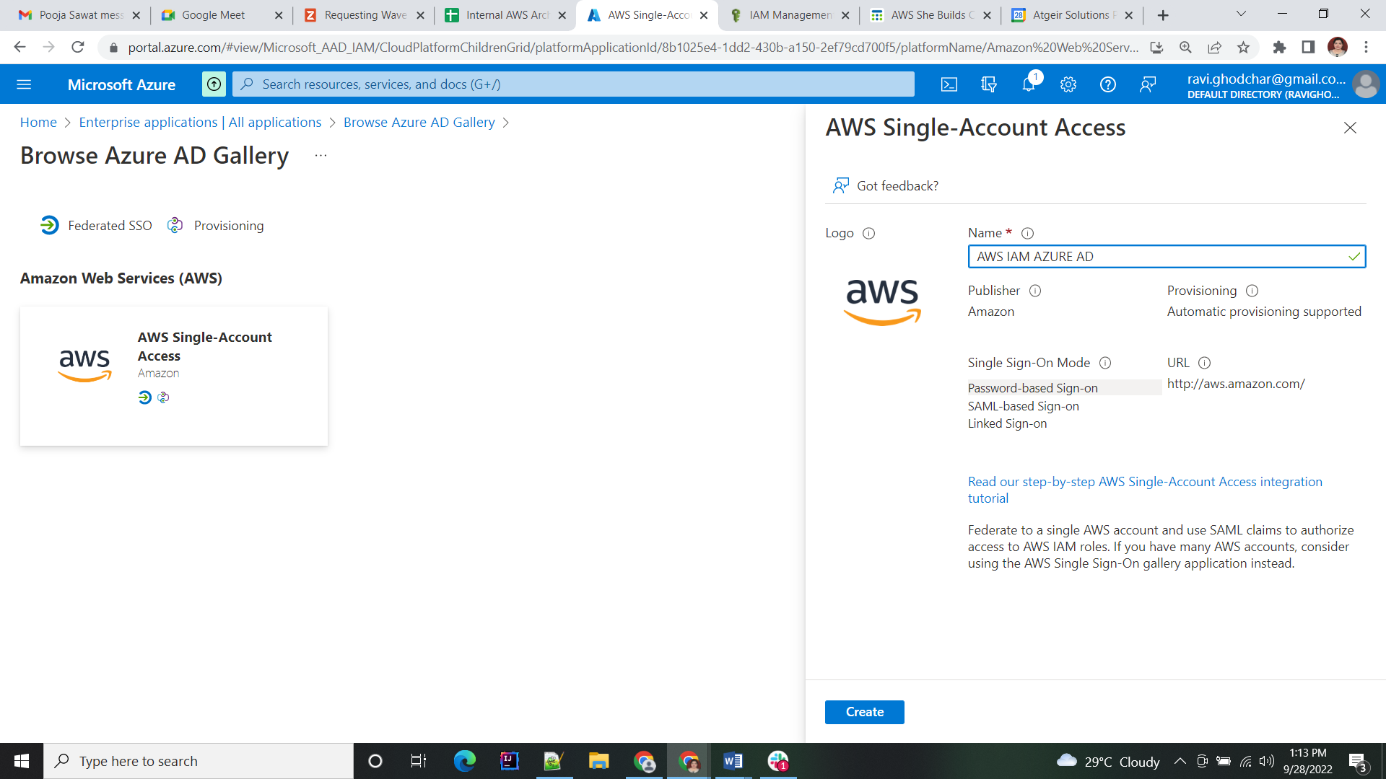

Click on create button and wait for a minute to add application.

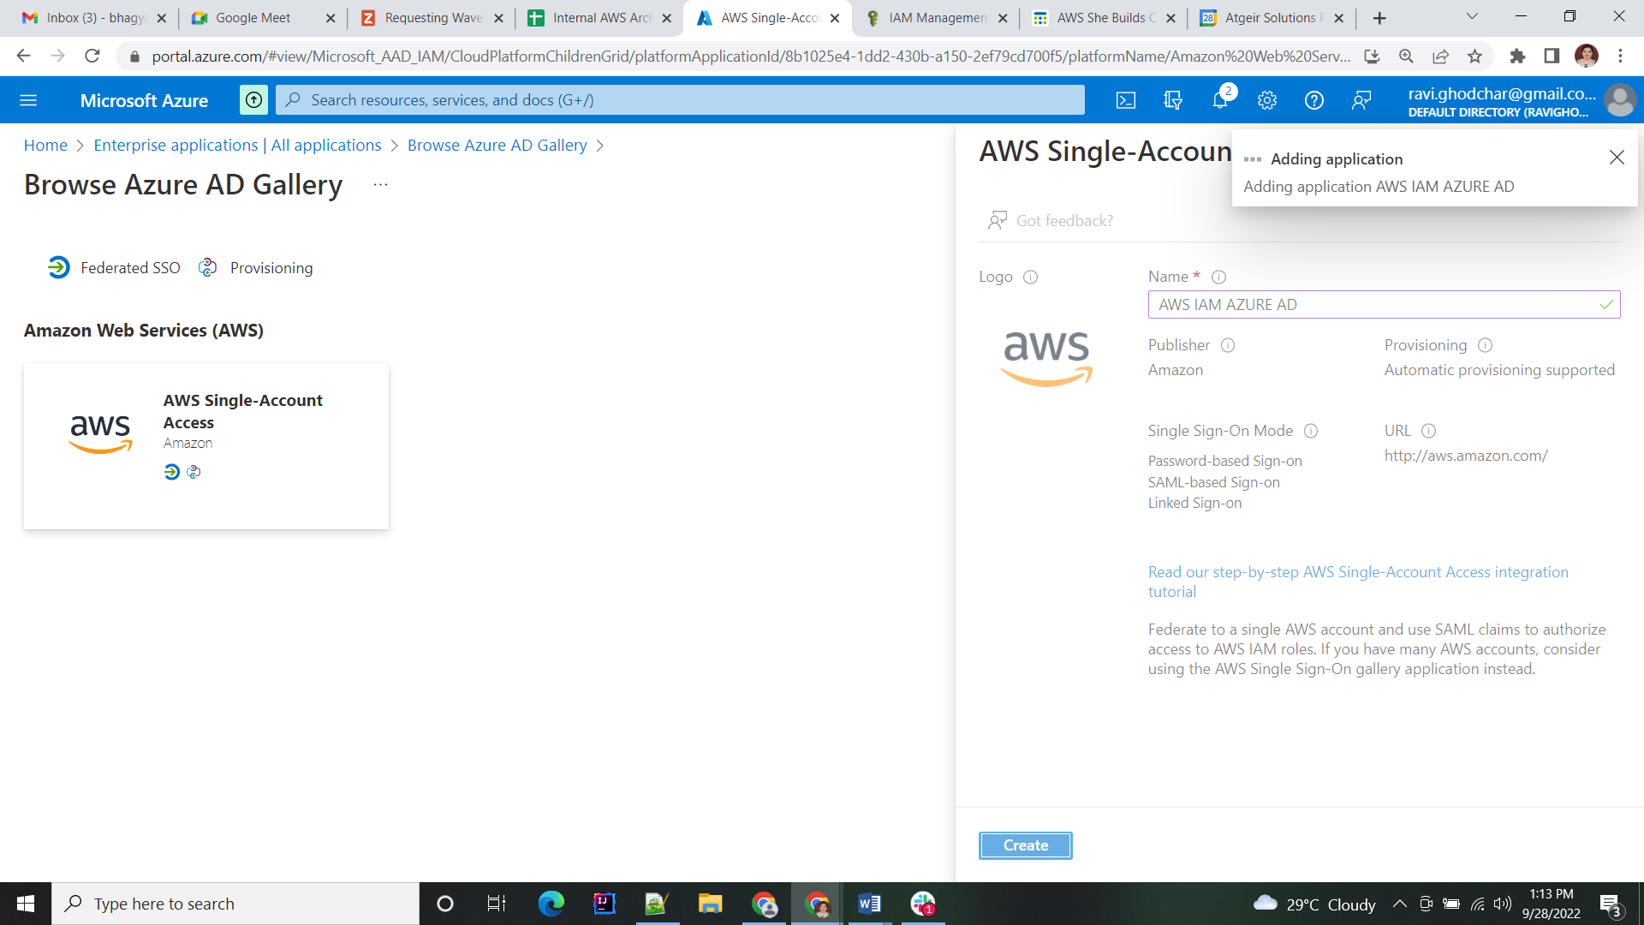

Now Application has been created.

### Configure SAML:

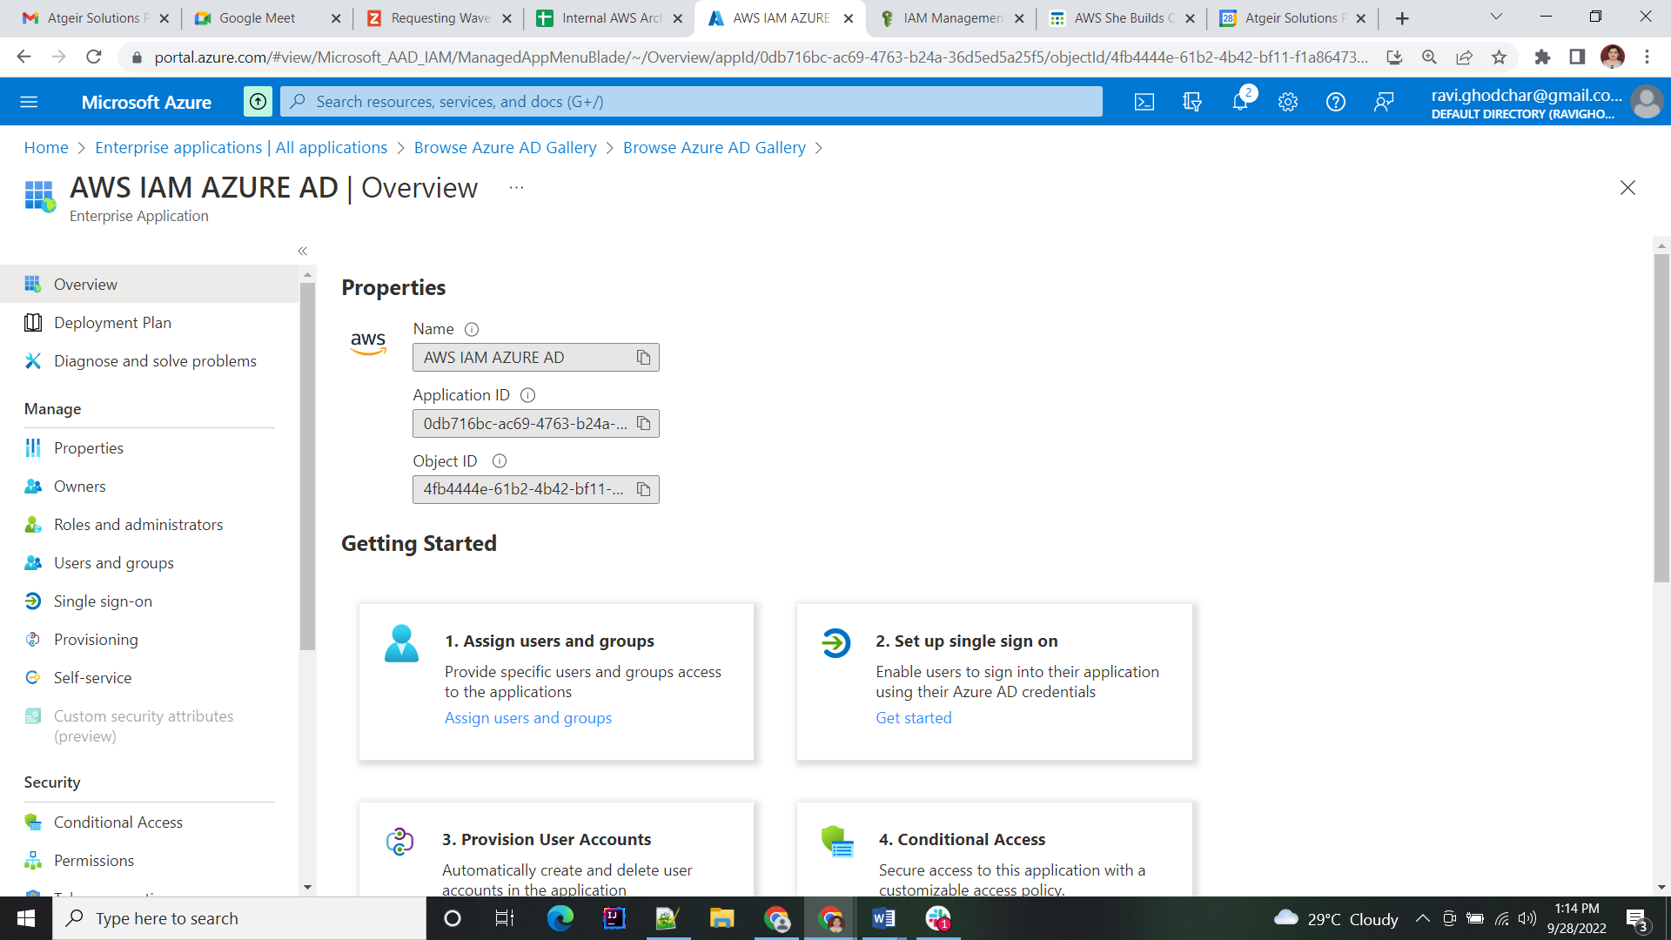

Click on SAML.

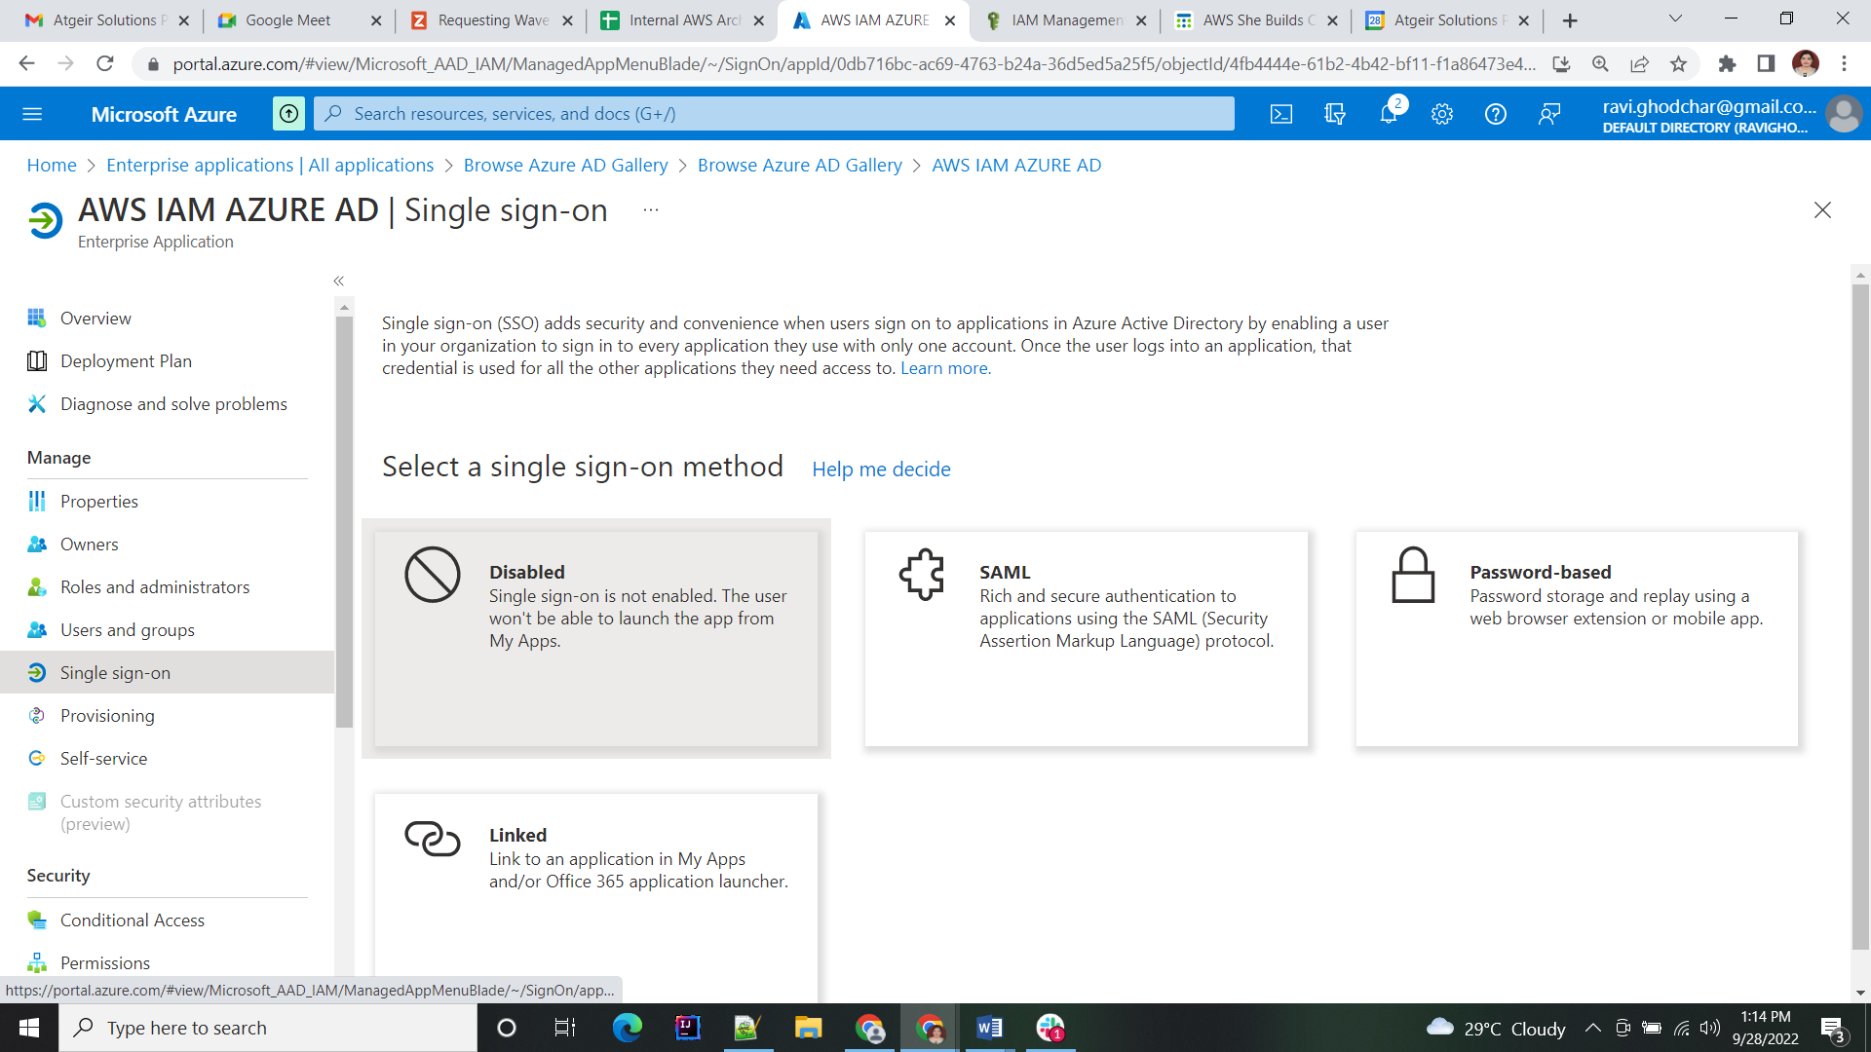

Go to the Single-Sign-On Tab.

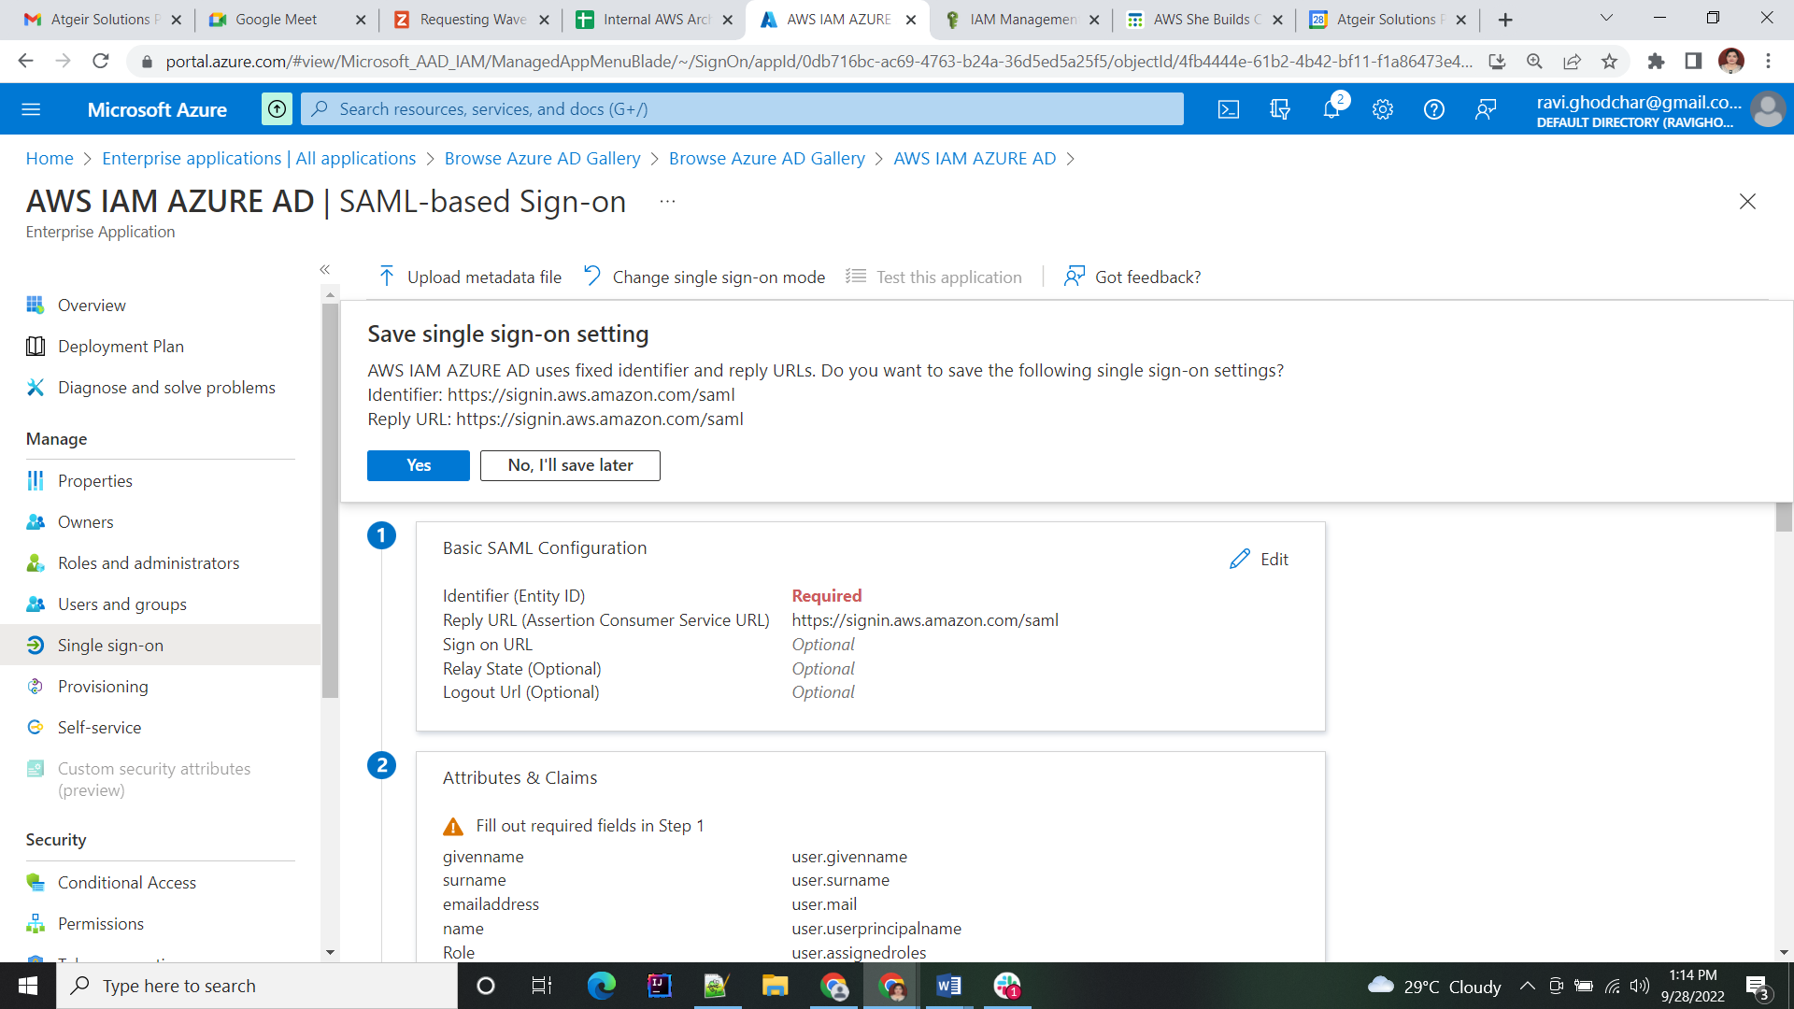

Edit Basic SAML Configuration.

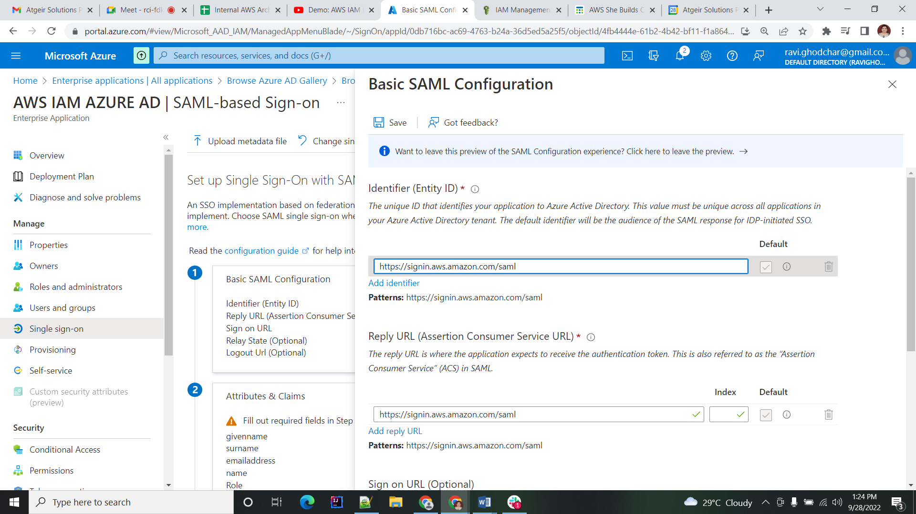

Review the Basic SAML Configuration settings and select**Save**.

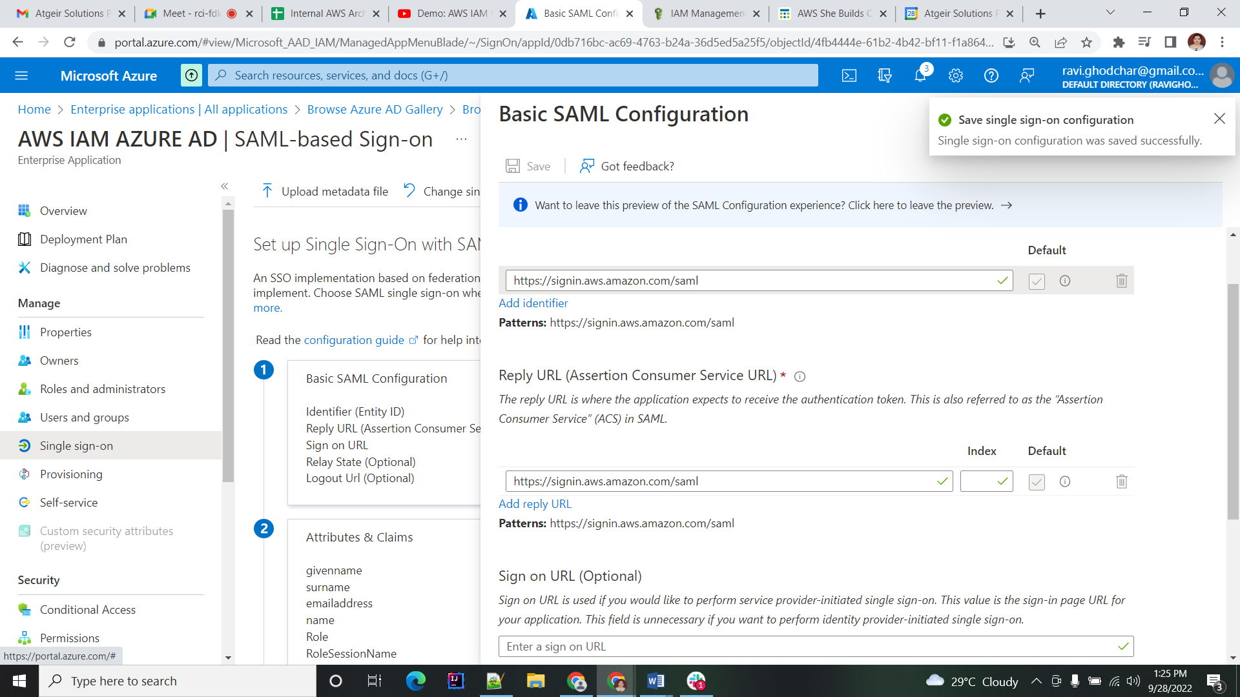

Select **Download** next to the Federation Metadata XML. This XML file is needed during the AWS configuration.

This concludes the Azure setup.

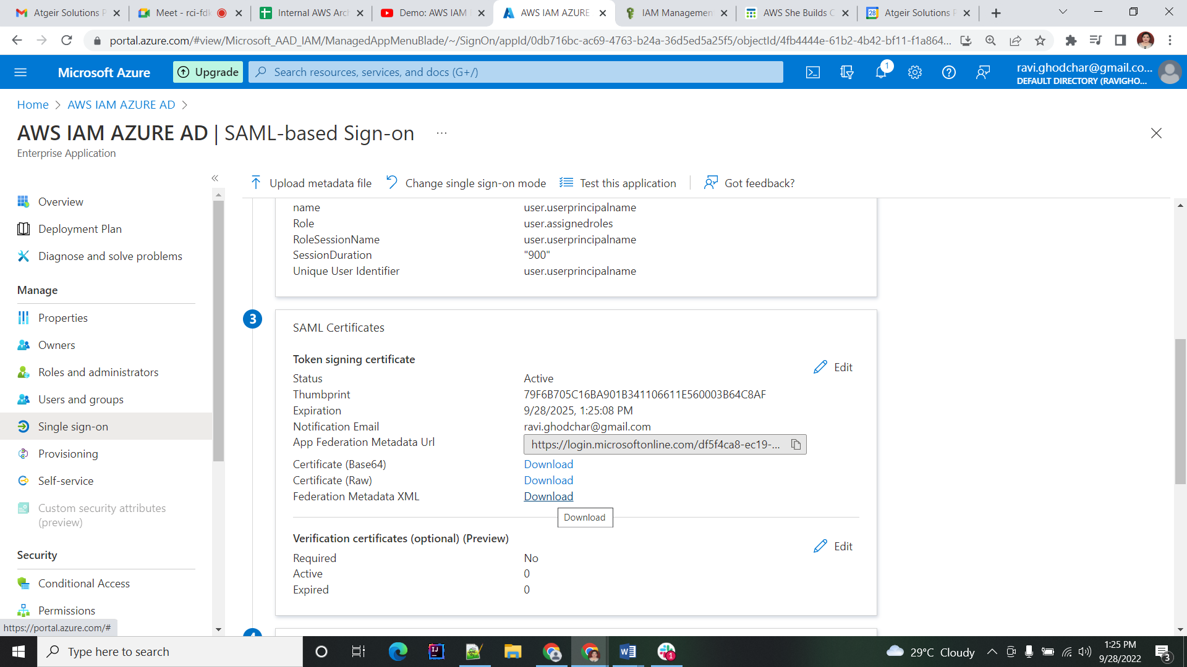

## Step2: Configure Target AWS Accounts

Now, we will configure the target AWS accounts for user access with single sign-on. Please note, the following configuration steps need to be implemented in each target AWS account, that should be enabled for the federated Azure AD authentication.

To get started, open the AWS console. In the navigation pane, under Identity and Access Management, choose **Identity providers**. For Provider type, choose **SAML**. For Provider name, enter **AzureAD**.

For Metadata document, upload the metadata XML file of the Azure AD enterprise application that was just downloaded and select **Save**.

### Create Identity Provider:

The name of the identity provider (IdP) needs to be equal to the name you have given in the regular expression replacement pattern of the claim rule in the Azure AD configuration.

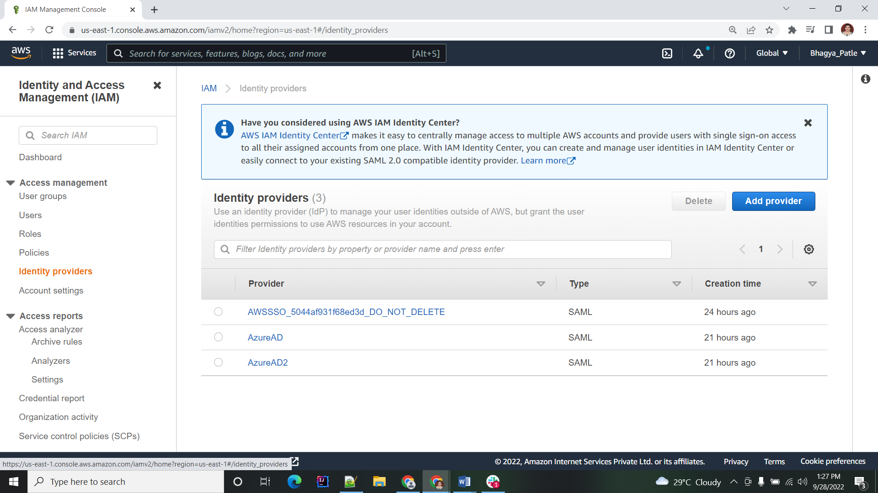

Click on Add Provider

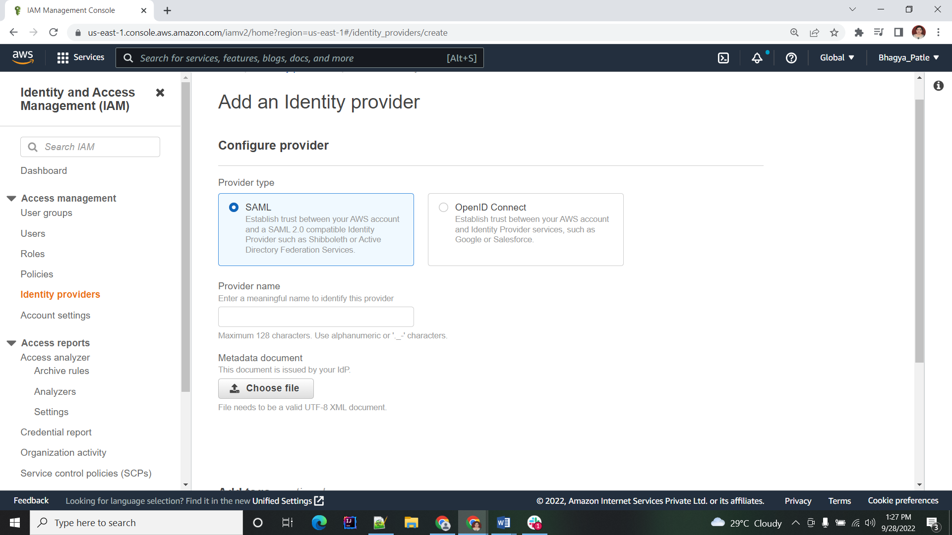

Select the provider type as SAML. Enter the provider name which you want. Also upload the metafile which is downloaded from AZURE Application.

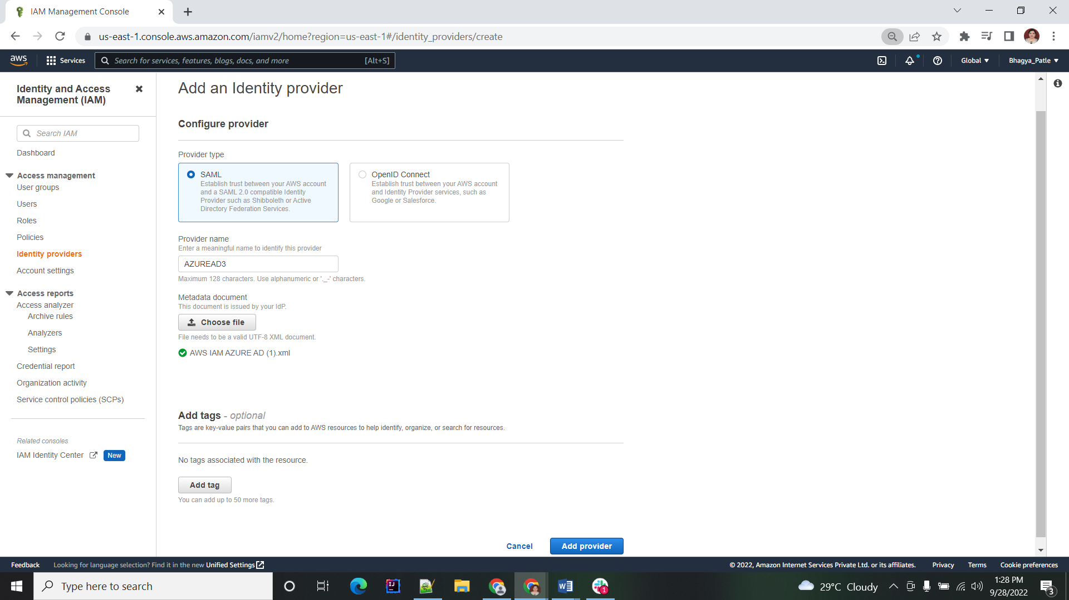

Created Identity provider is added in the list.

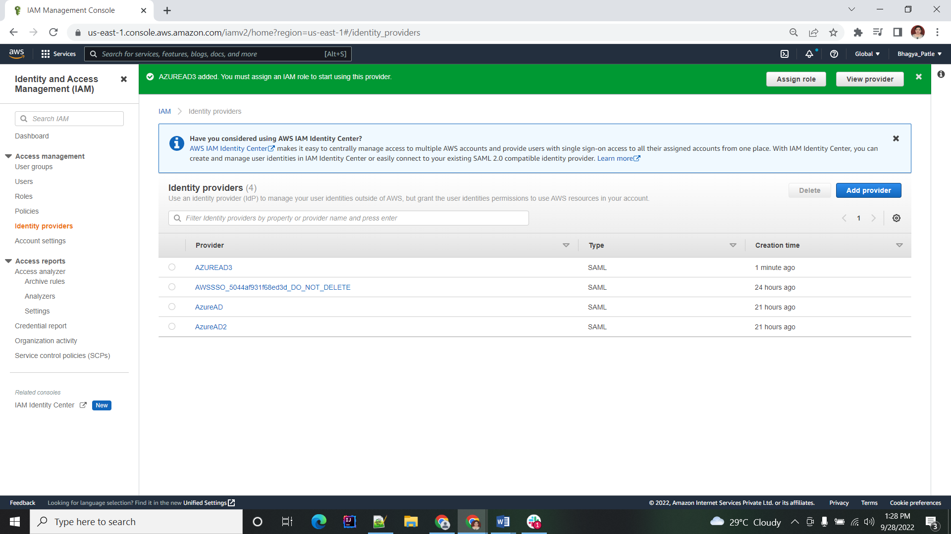

### Create Role:

Next, create an IAM role. For Type of trusted entity, choose **SAML 2.0 federation**. For SAML provider, select the newly created SAML provider (in this case, AzureAD).

Select **Allow programmatic and Management Console access**. This will create a condition in the policy document.

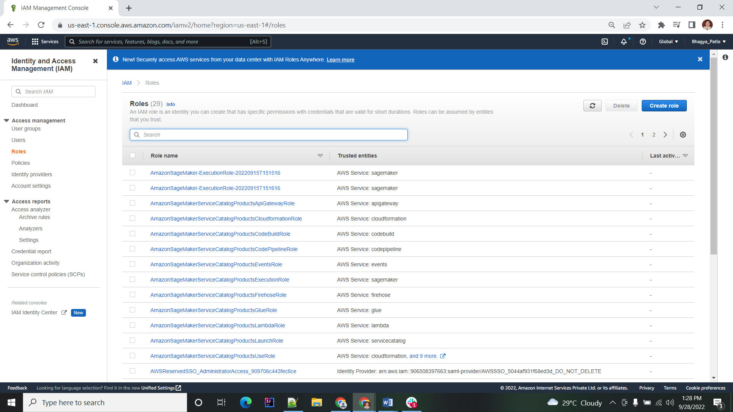

Select the trusted entity type as SAML 2.0 federation. Select the identity provider which is created earlier.

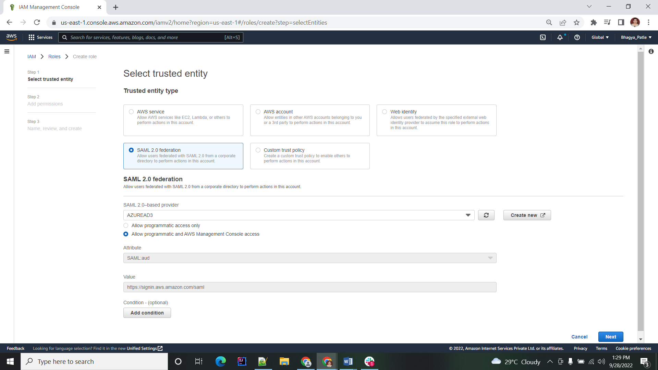

Finally, select the necessary permissions (for example, **SupportUser**) and insert a role name to save the IAM role. The role name needs to comply with the corresponding group name in Azure AD (excluding the prefix and AWS account ID).

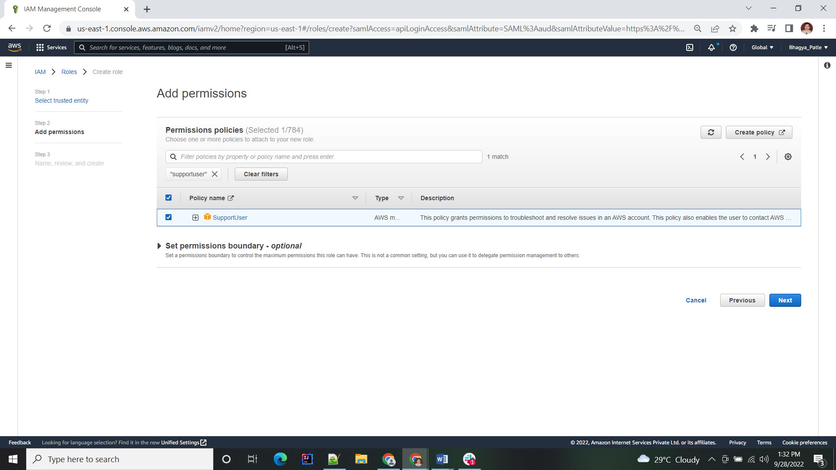

Enter the Role name which you want. Click on create role.

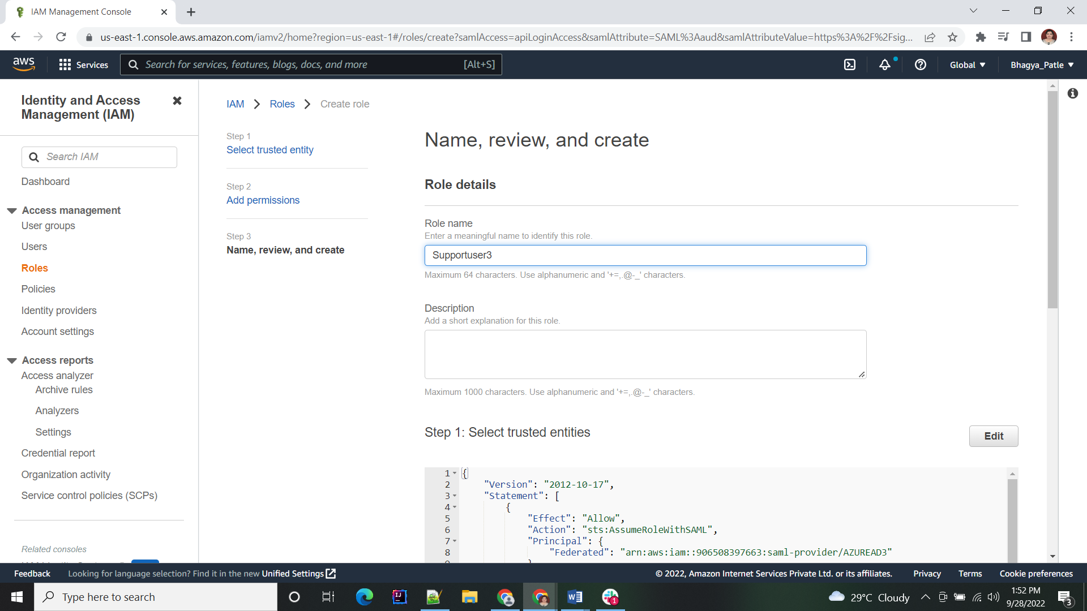

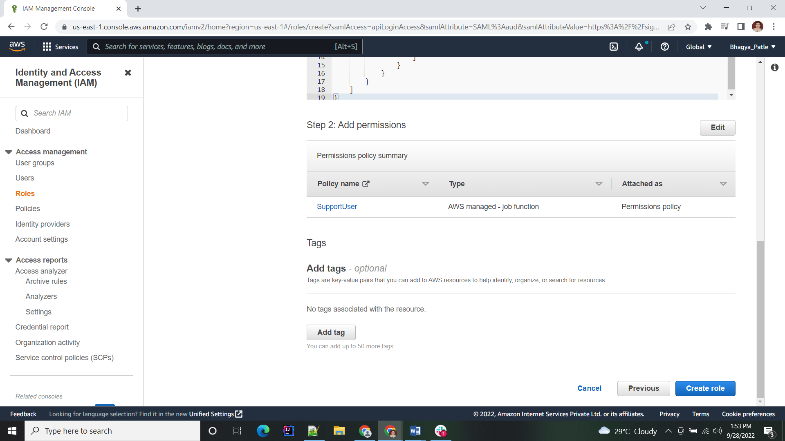

Repeat the role creation for all relevant roles.

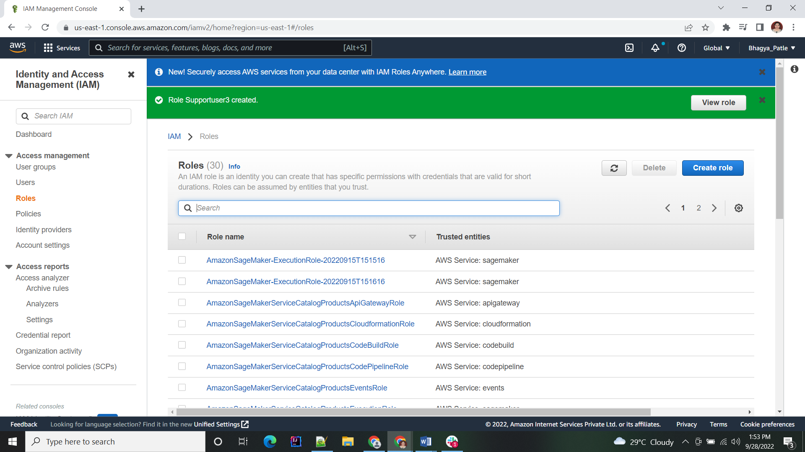

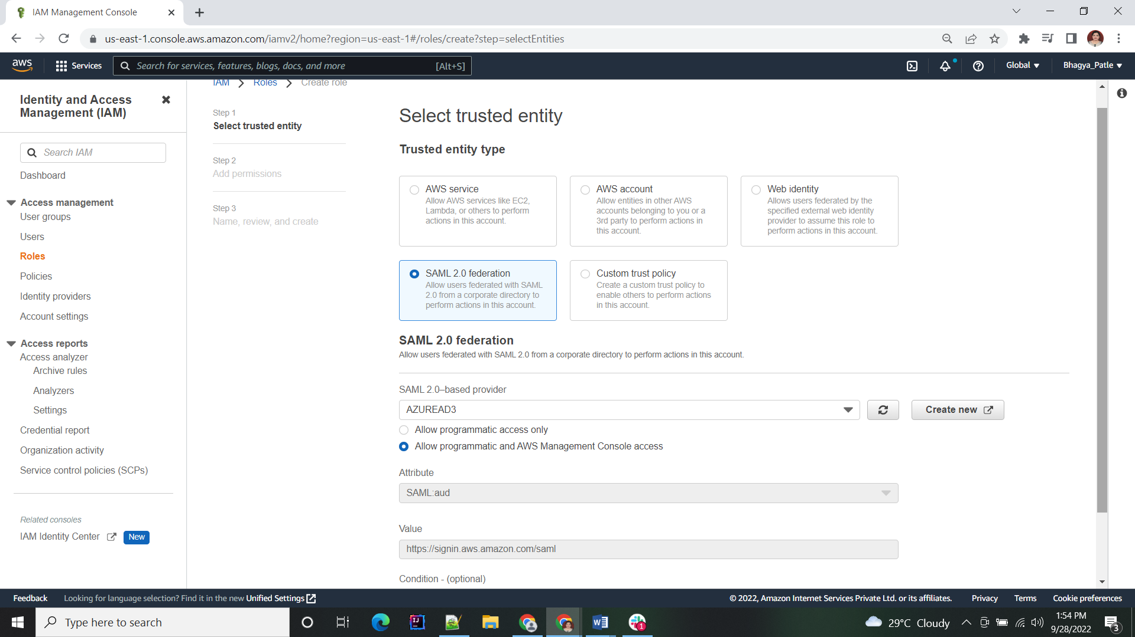

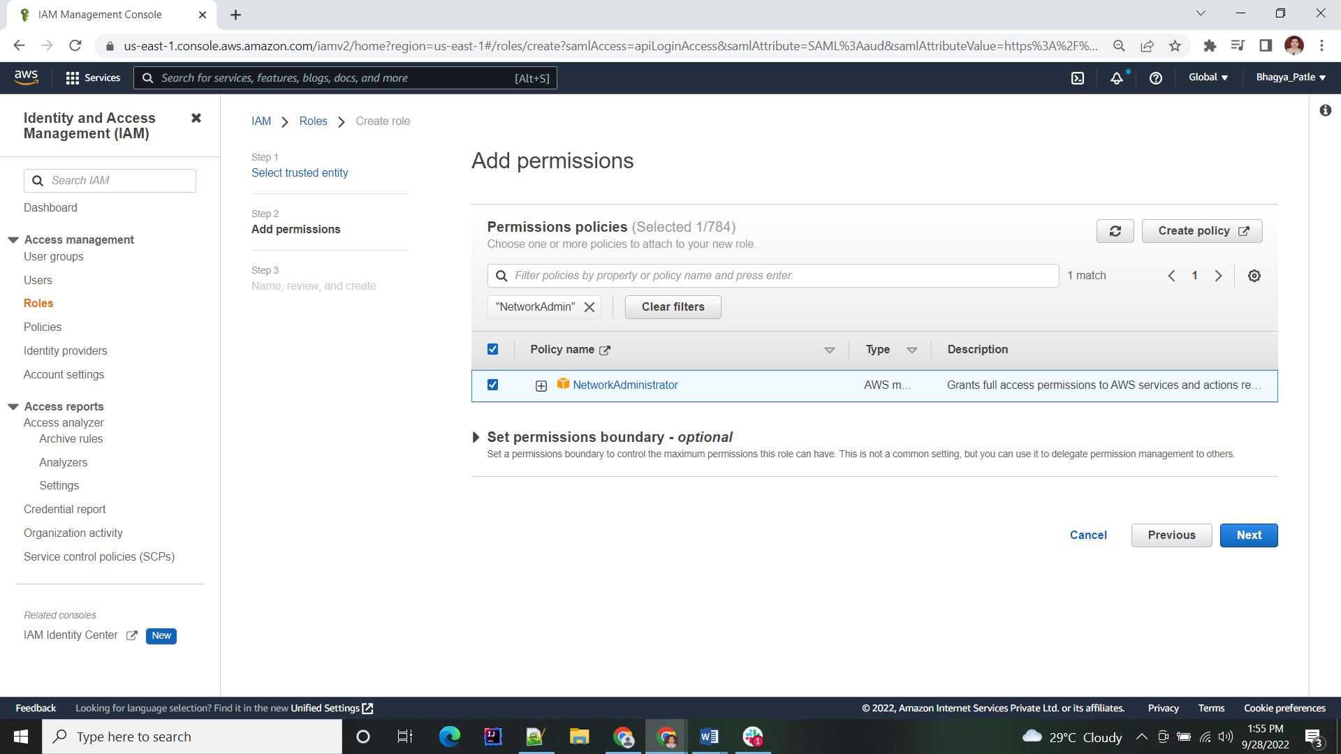

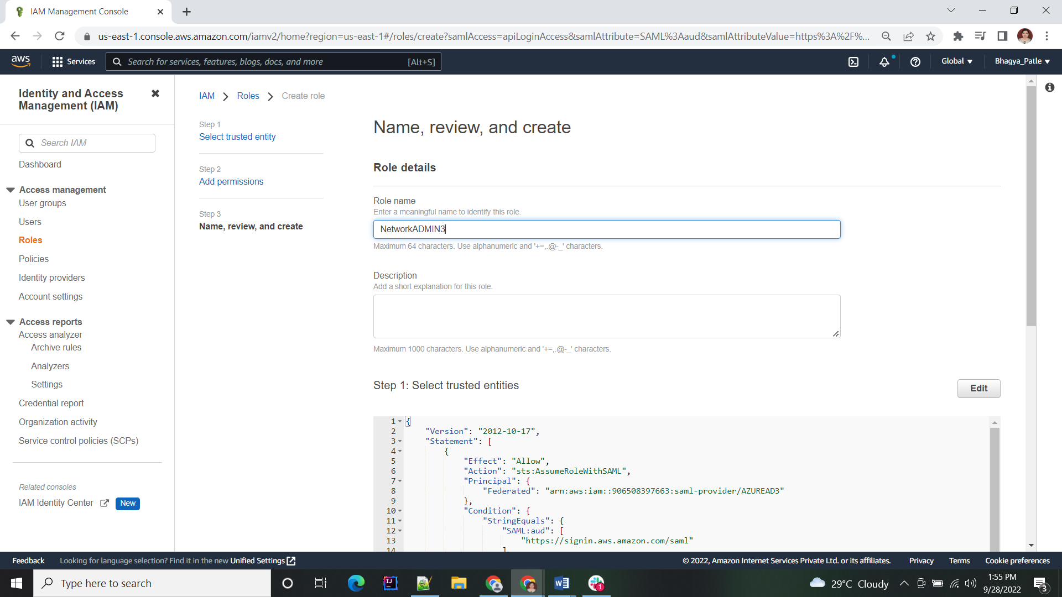

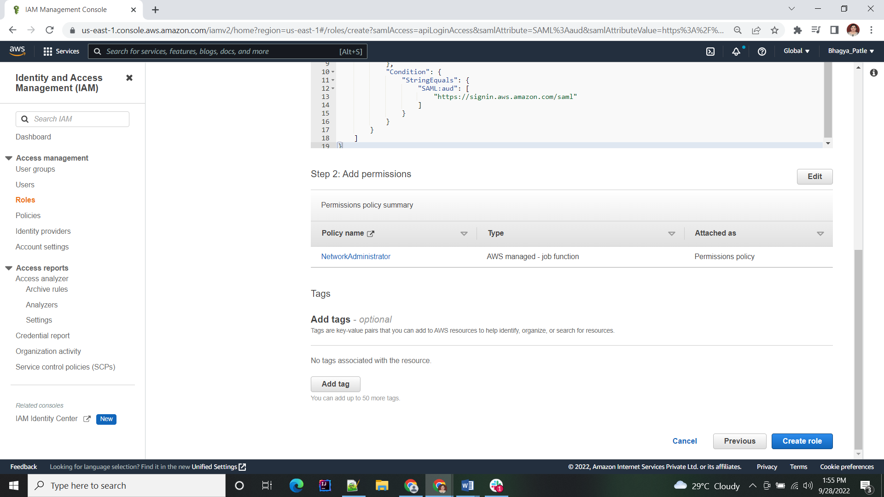

Till Now we have created 2 roles namely SupportUser and NetworkAdministrator.

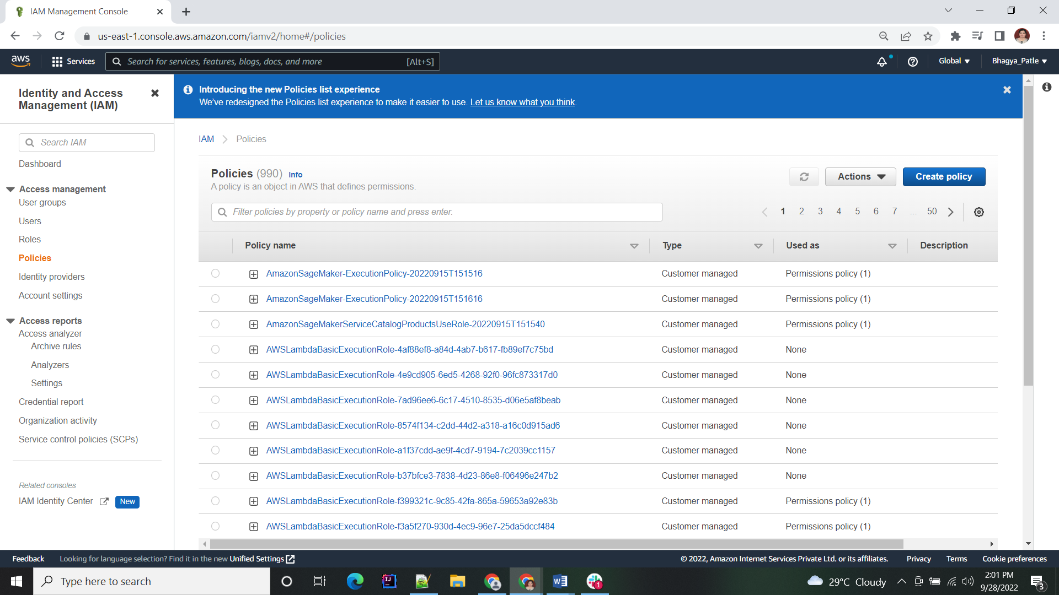

### Create a policy:

Select the service as IAM.

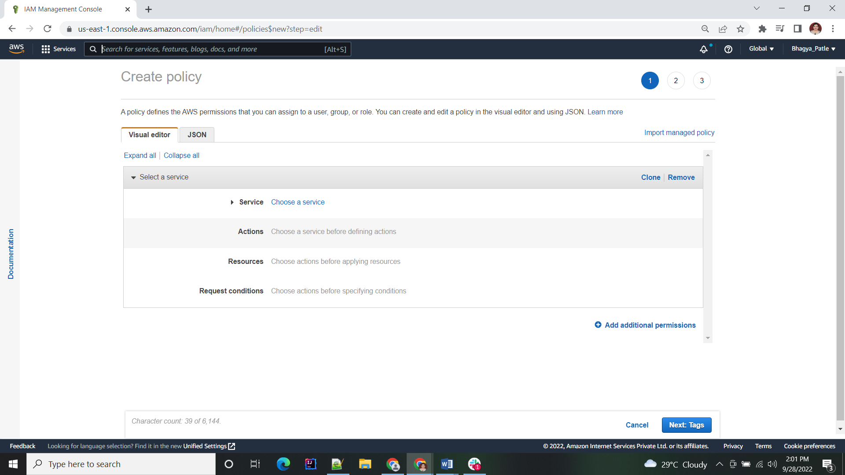

Enter the actions. Add the ListRole in select bar and check it.

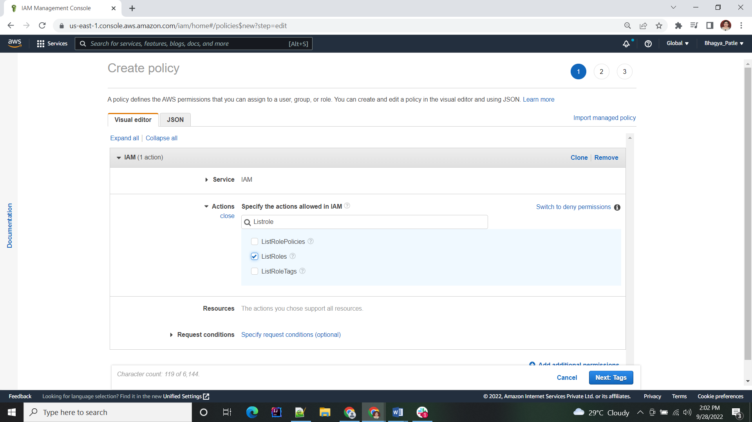

Give the name to the policy.

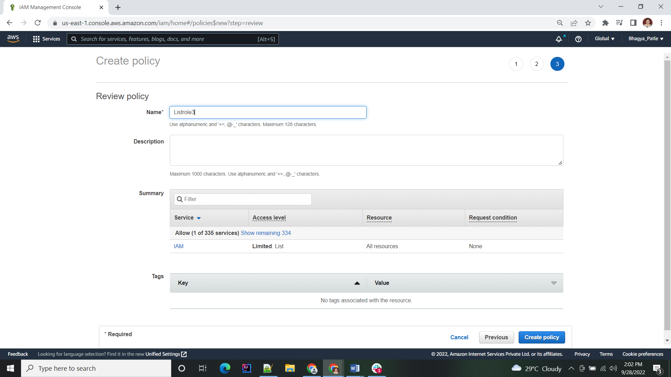

### Create User:

Create user by clicking on create user.

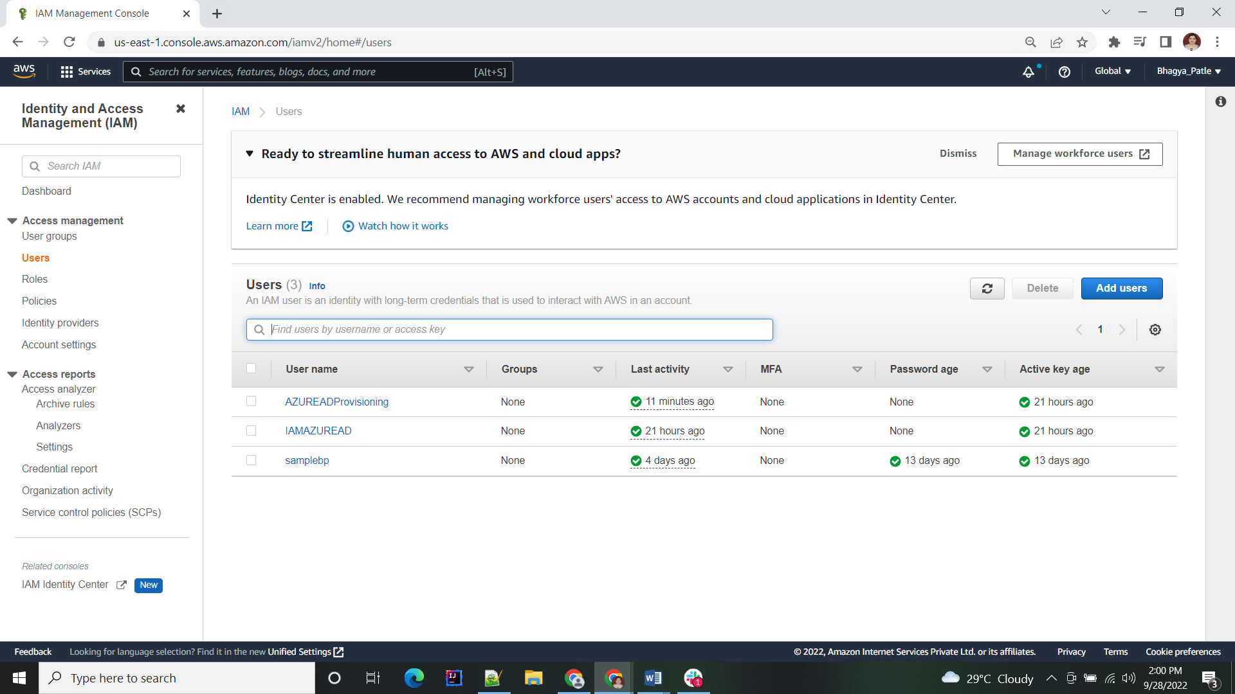

Add the name of user and select the AWS acess type as Access key- programmatic access.

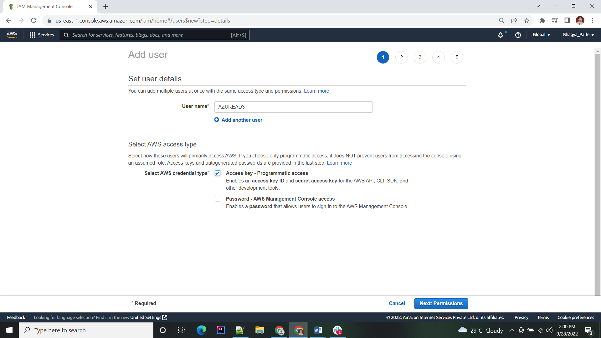

Attached the policy which are created in earlier step i.e. ListRole.

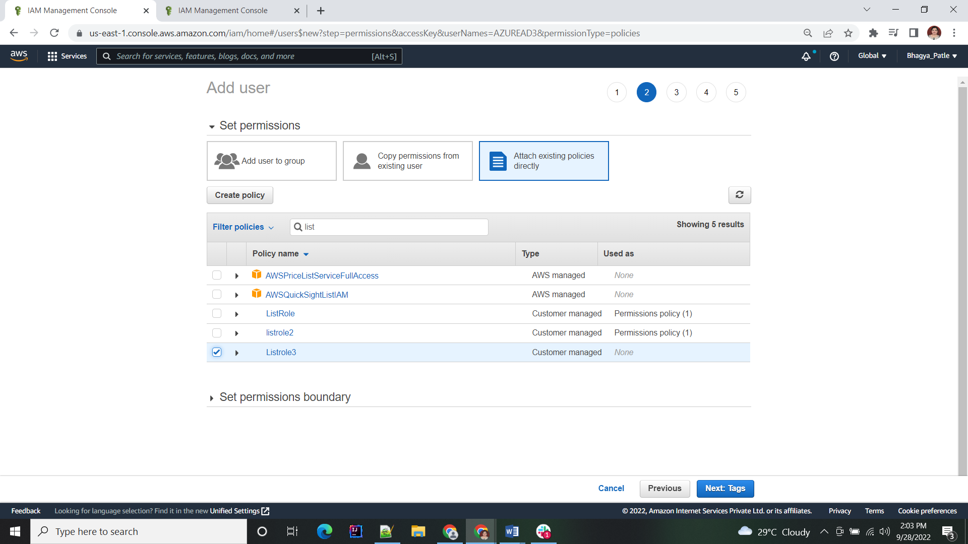

After clicking on create user will get following window save the .csv file to add credentials in Azure AD.

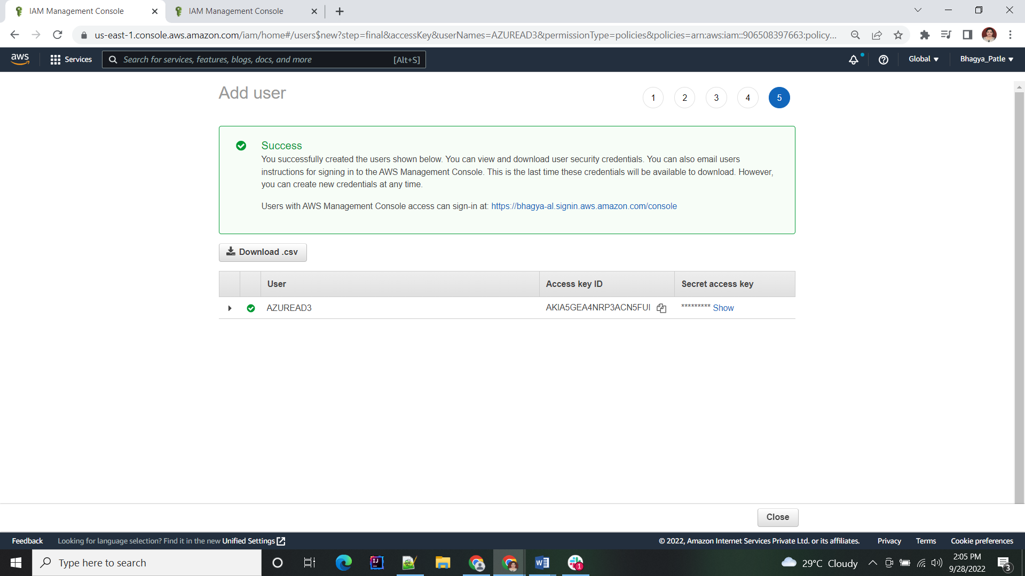

With this, the AWS configuration is complete.

## Step3: Integration Test

Once the setup is ready, single sign-on can be tested. To do this, open a browser and log in to the user access URL of the Azure AD enterprise application.

This will redirect you to either the AWS console, if only one role has been created, or prompt you to choose a role of an AWS account if multiple roles in one or different AWS accounts have been created.

### Perform Provisioning:

Get started with provisioning.

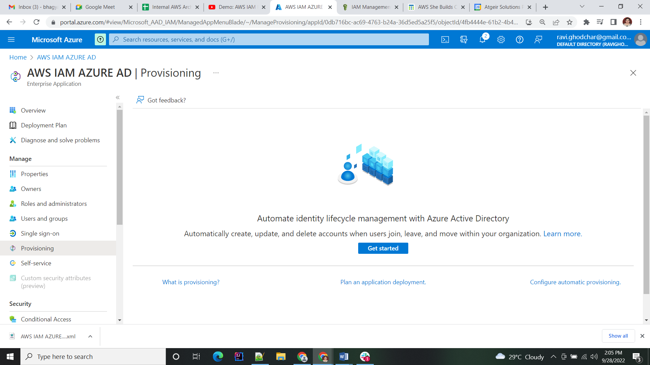

Change the provisioning mode manual to automatic.

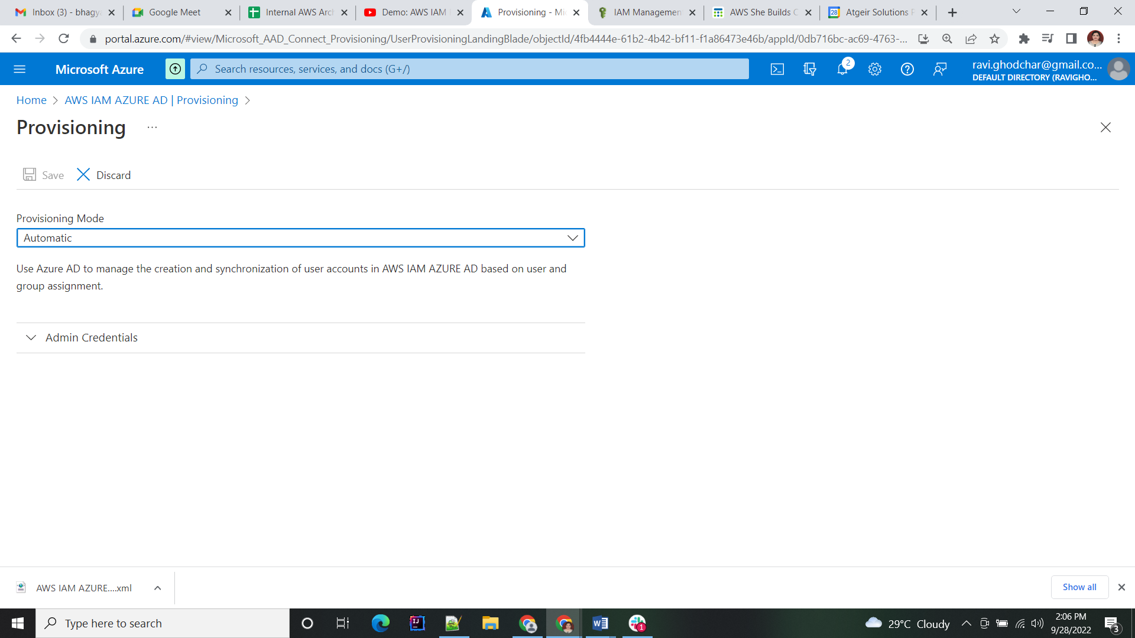

Enter the Admin credentials from AWS from the .csv file which we downloaded.

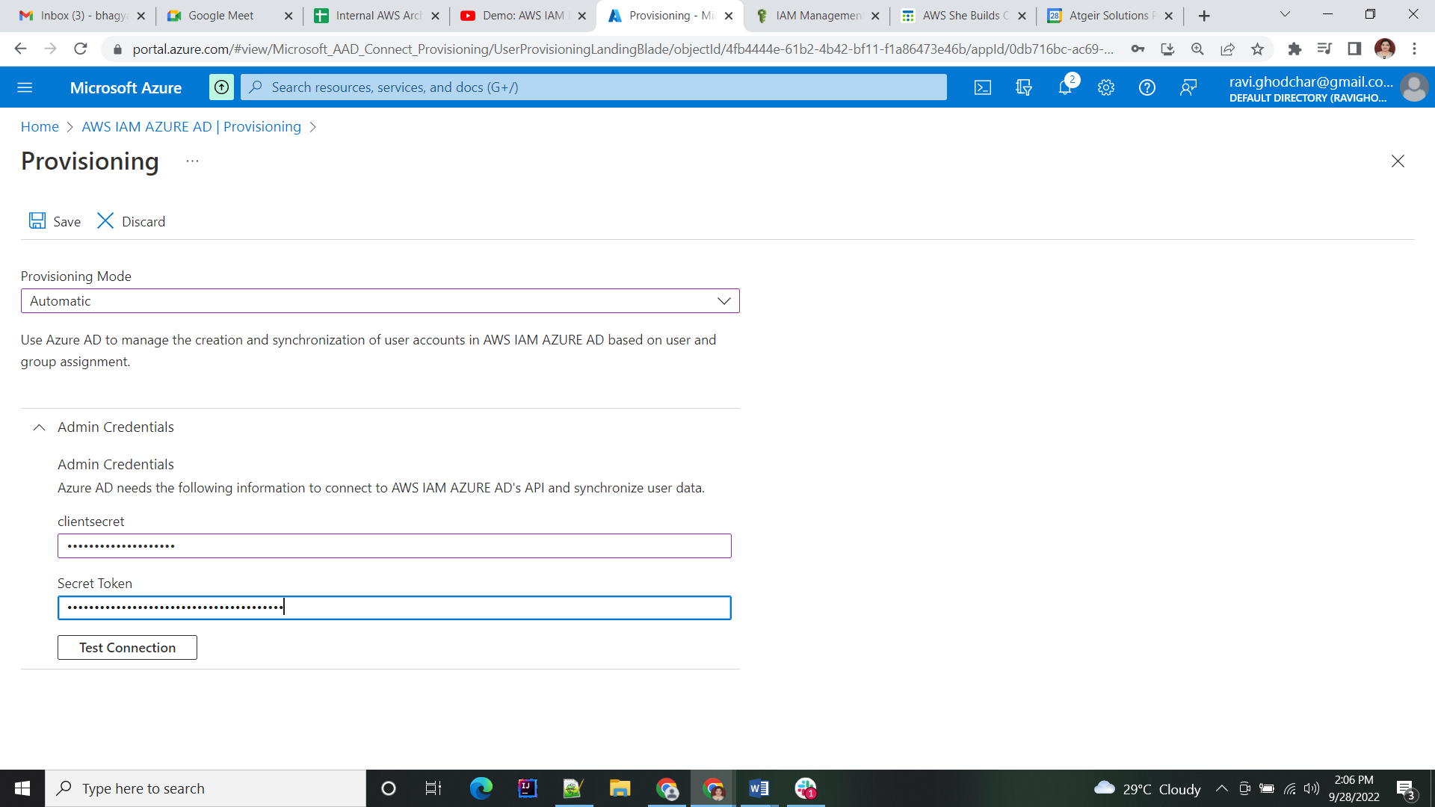

### Test the Connection

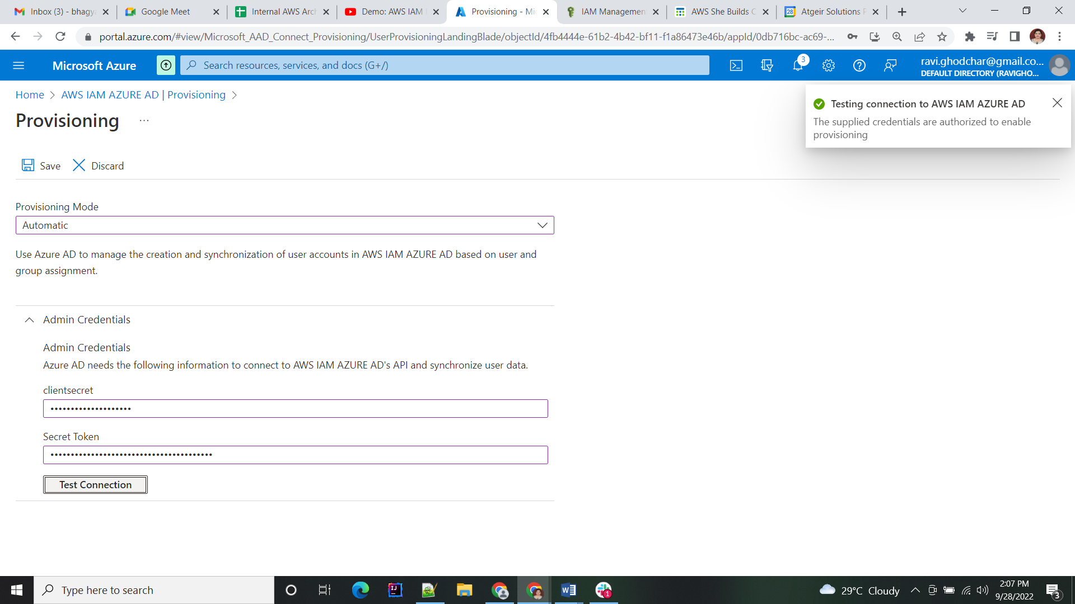

Start the provisioning for the first time. It will get automatically after every 44 mins.

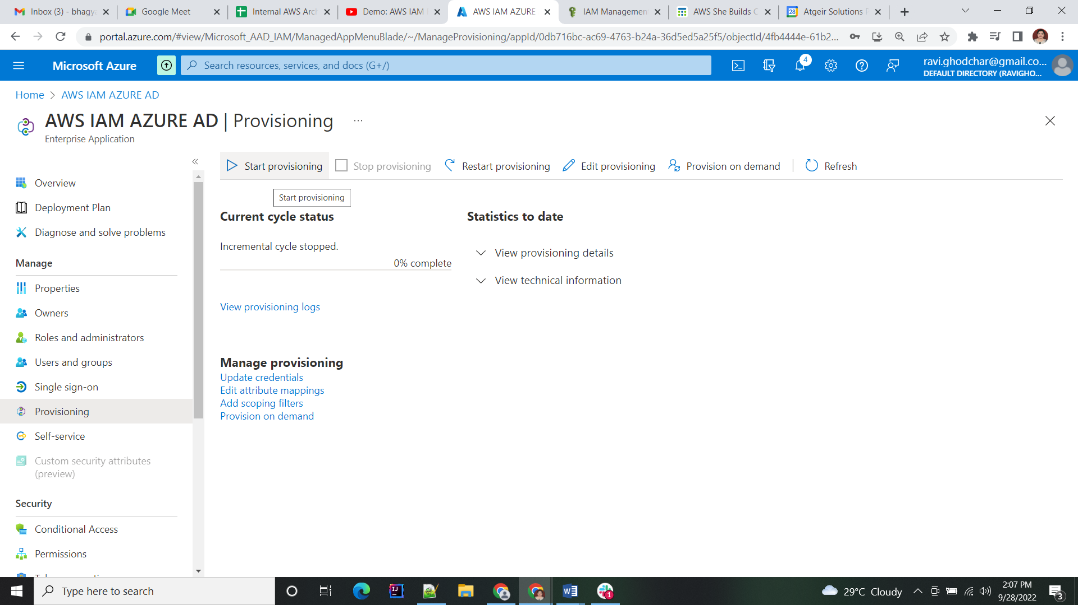

In our case 2 roles will be created.

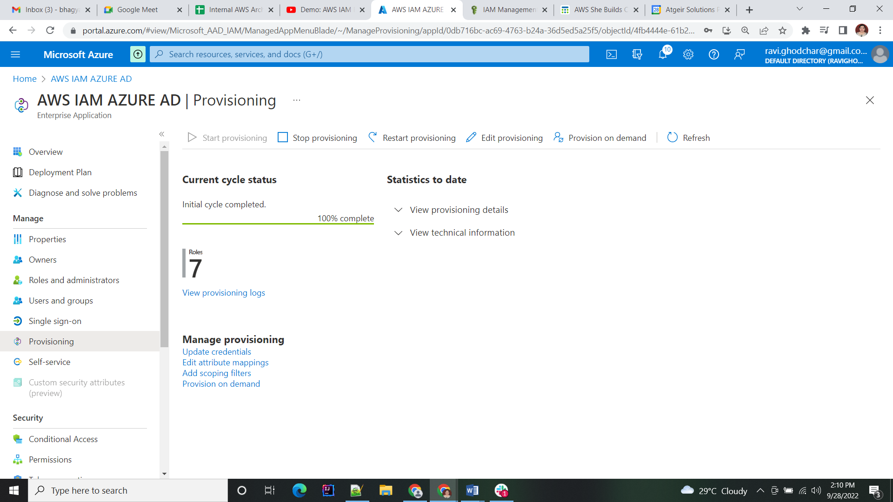

### Assign Users:

Add the users to the application by clicking on Users and group tab.

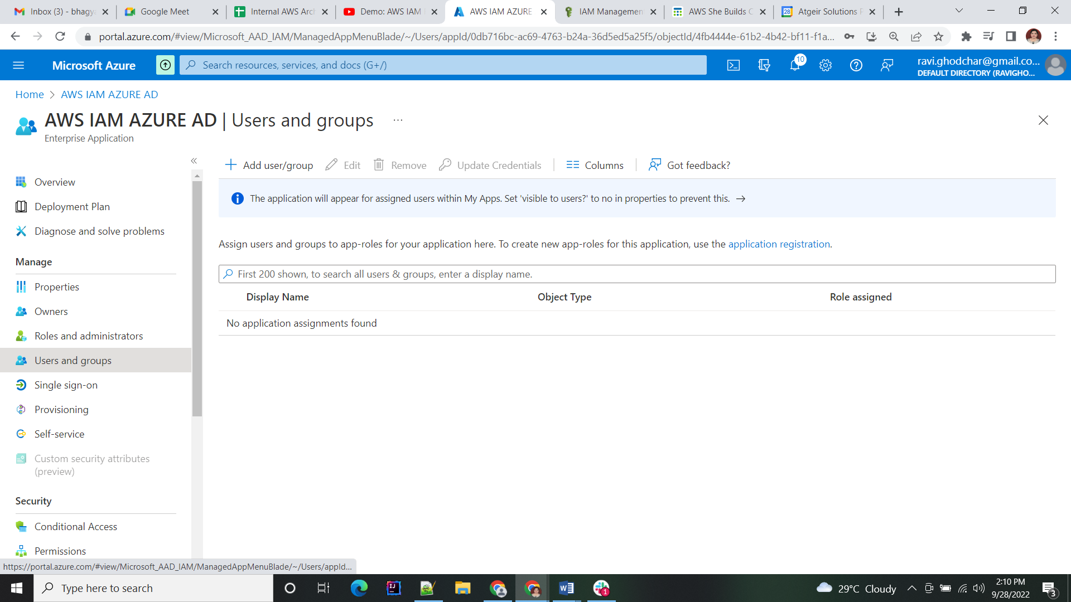

Select the users and assign the roles also.

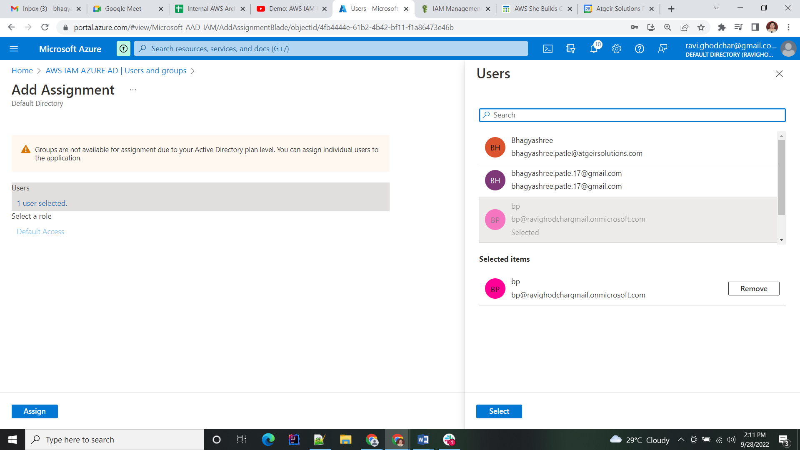

### Test Application:

Click on Single Sign-on tab and click on Test single sign-on with Application.

Select the sign in as current user.

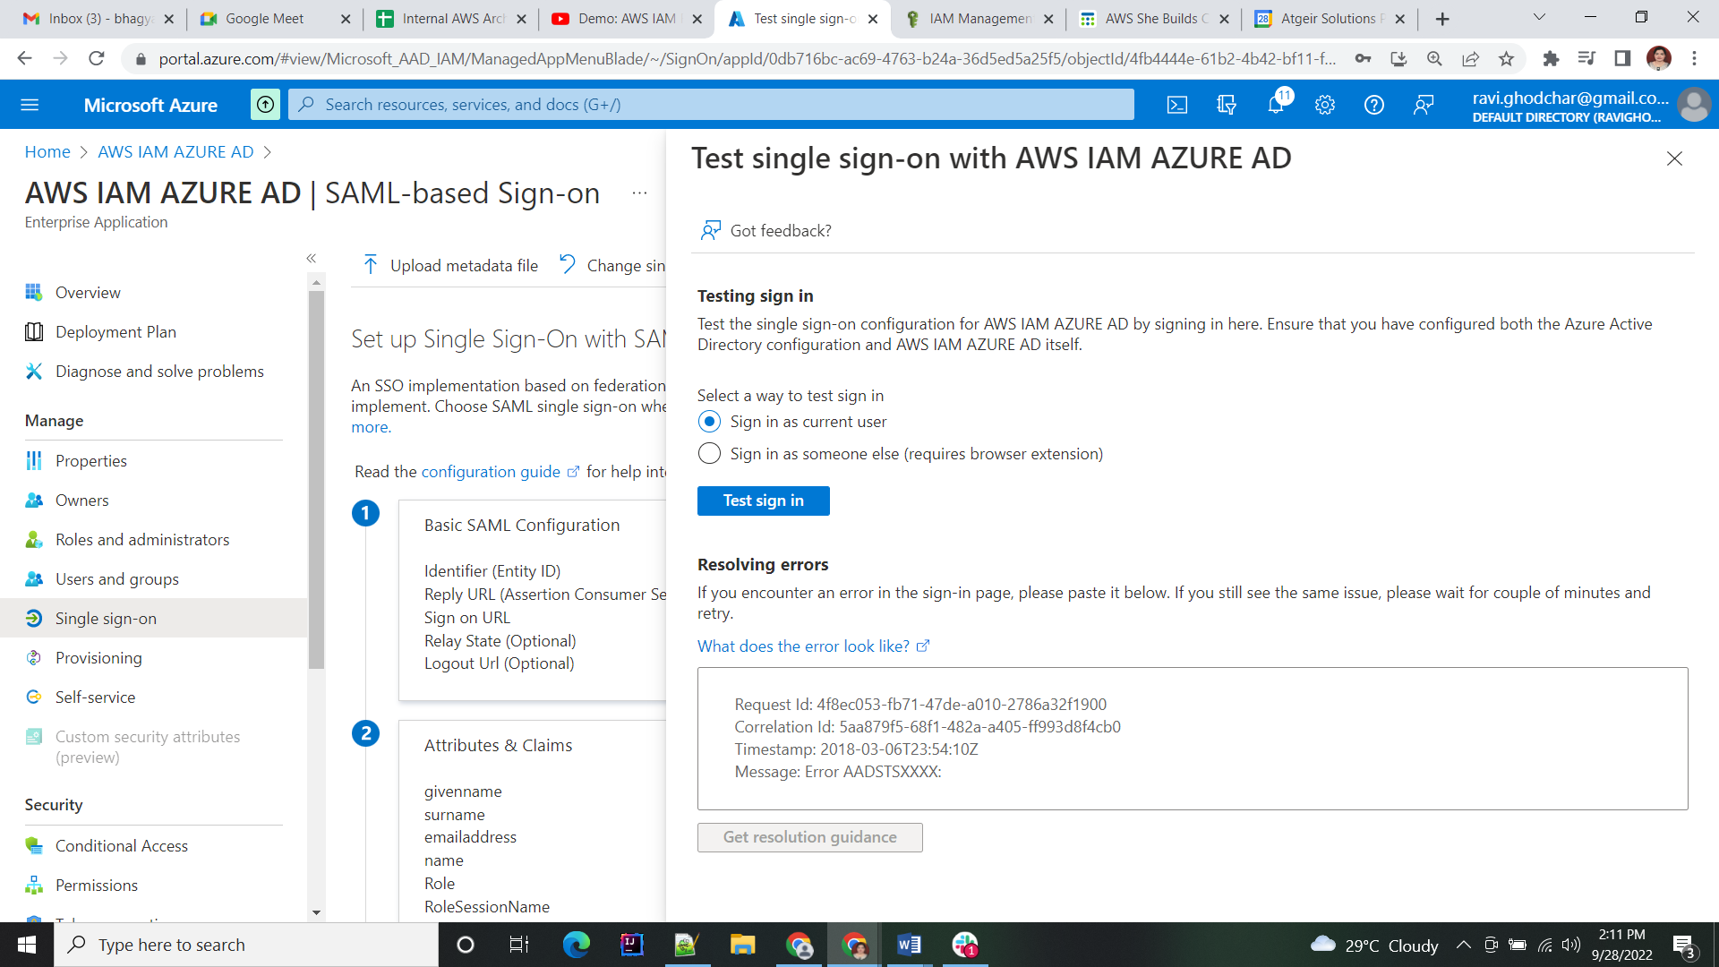

Enter the username and password of the member of this azure account. Only member and current user can access the Application.

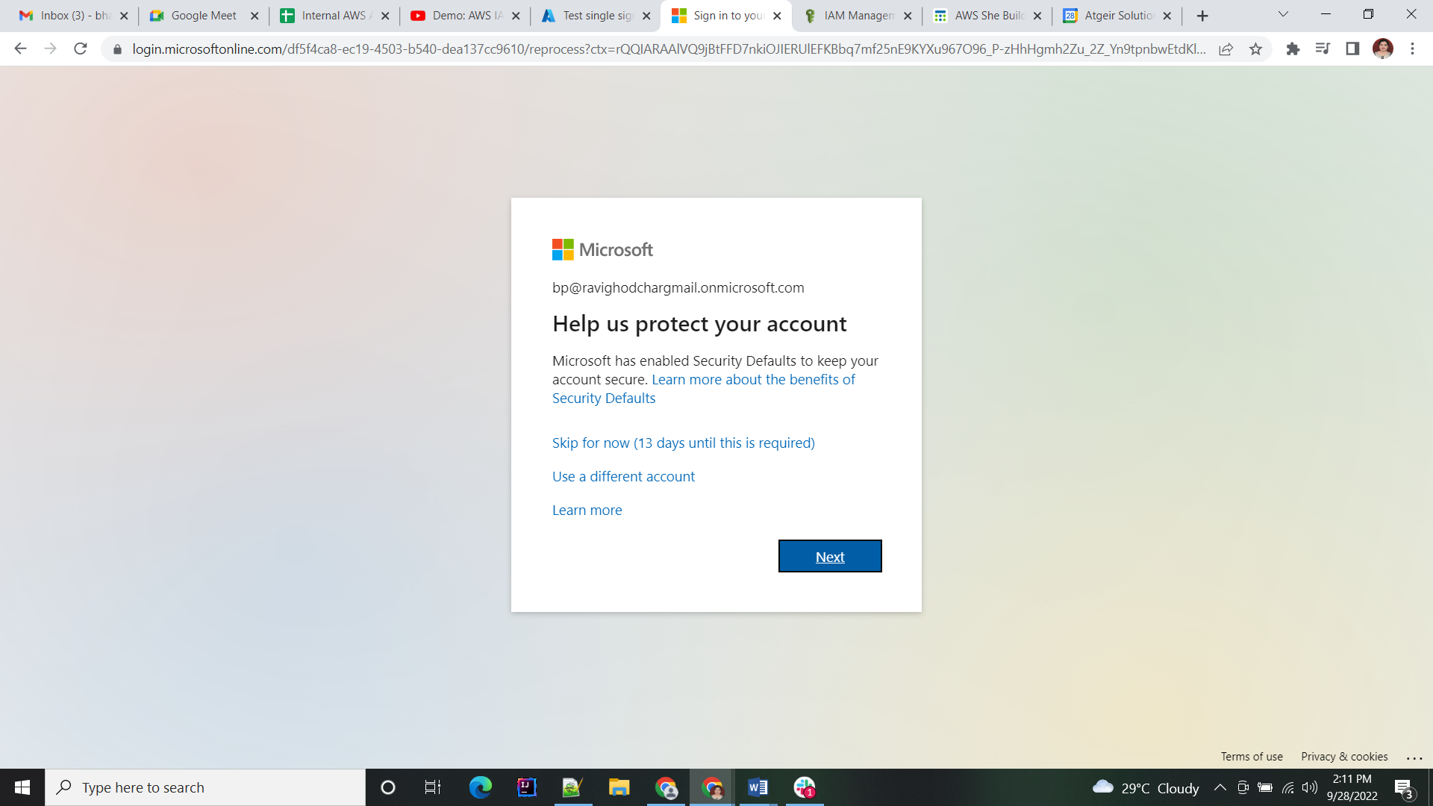

After login select the role which you want. Now in this step you are signing the AWS account through the azure account.

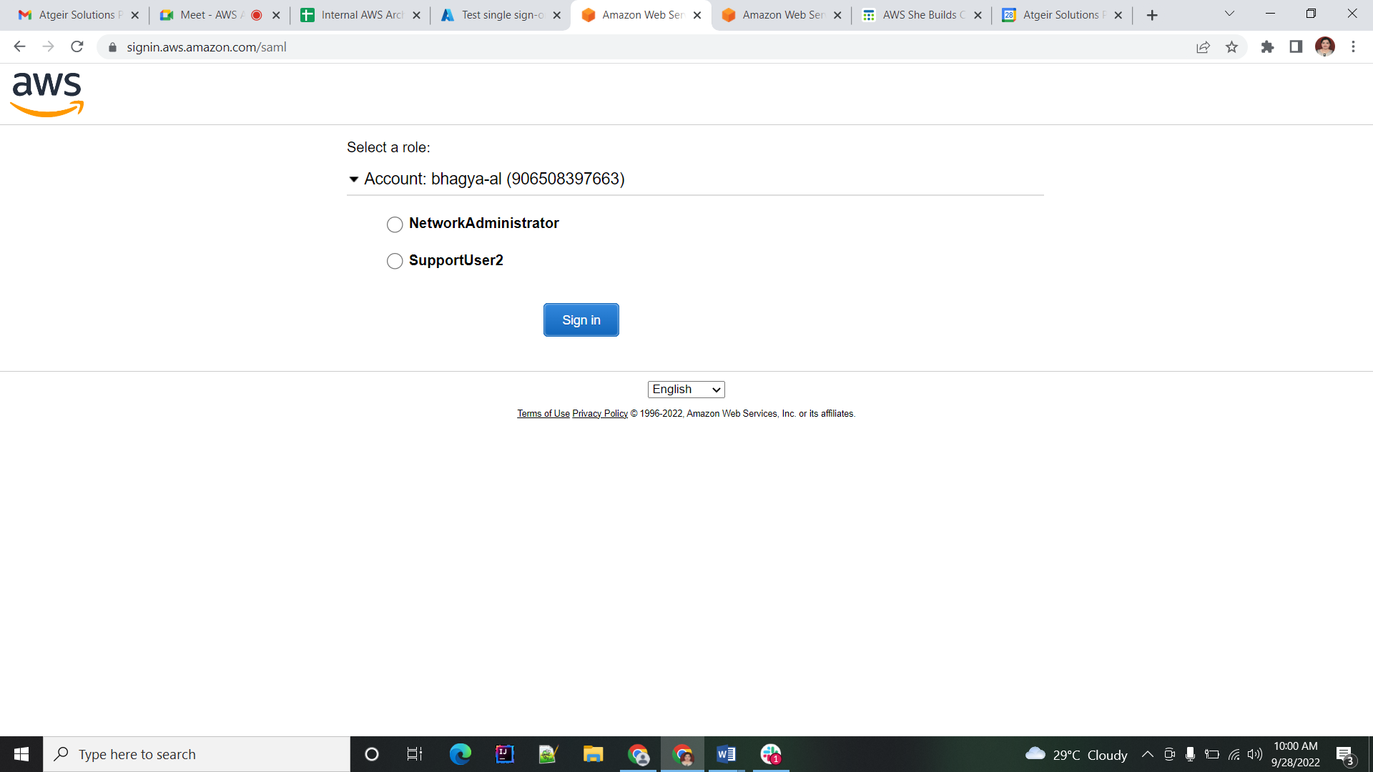

Selecting NetworkAdministrator Role you will get below window. See in the right corner NetworkAdministrator is present

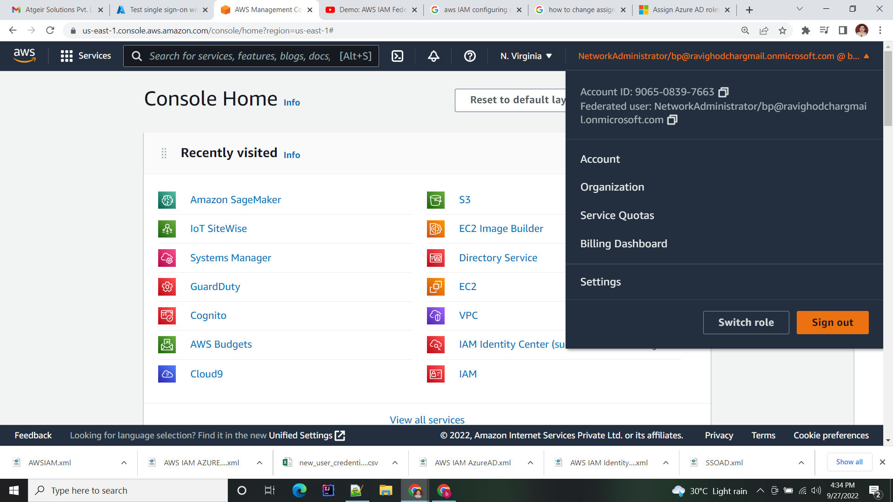

# Useful Link:

https://www.youtube.com/watch?v=hANDWau9NvE